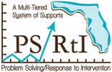
Unpacking Standards Worksheet
Step 1: Identify Standard
Step 2: Record the skills students are expected to do (verbs and action phrases). | Step 3: Record the knowledge and concepts students are expected to know and understand (nouns and noun phrases).
Step 4: Record the pre-requisite knowledge and skills implied by the standard (implied knowledge and skills). | Step 5: Record the instructional implications of the standard (instruction needed to ensure student mastery of the standard).

