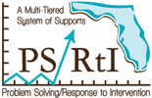
Lesson Study Cycle Steps 1-4.
Lesson Study teams can use this reflection document throughout Lesson Study Professional Learning series to capture big ideas, key thoughts, critical learning related to implementation of Lesson Study.
Lesson Study Reflections
K | Q | T
What I Know about Lesson Study? | What Questions do I or my team still have about Lesson Study | What are my Thoughts about Lesson Study?

